R Tarun Kumar
1BM19CS229
BDA LAB 4

1. Create a key space by name Library

2. Create a column family by name Library-Info with attributes Stud_Id Primary Key,
Counter_value of type Counter,
Stud_Name, Book-Name, Book-Id, Date_of_issue

3. Insert the values into the table in batch

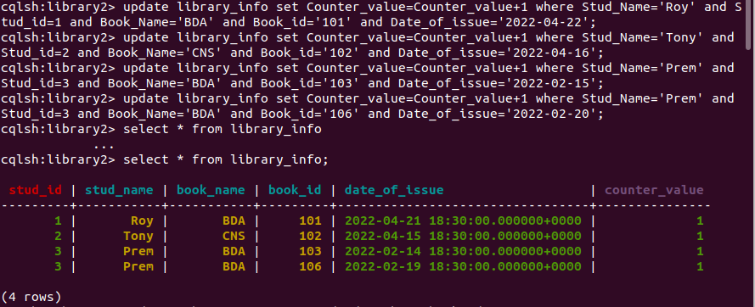
4. Display the details of the table created and increase the value of the counter

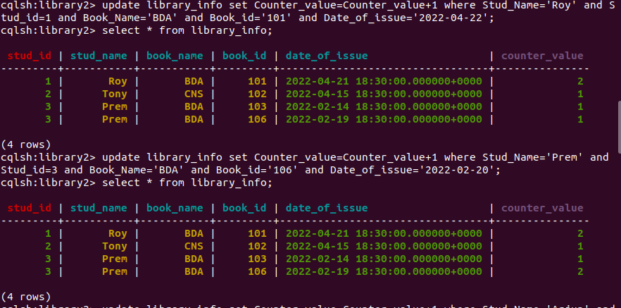

5. Write a query to show that a student with id 112 has taken a book “BDA” 2 times.

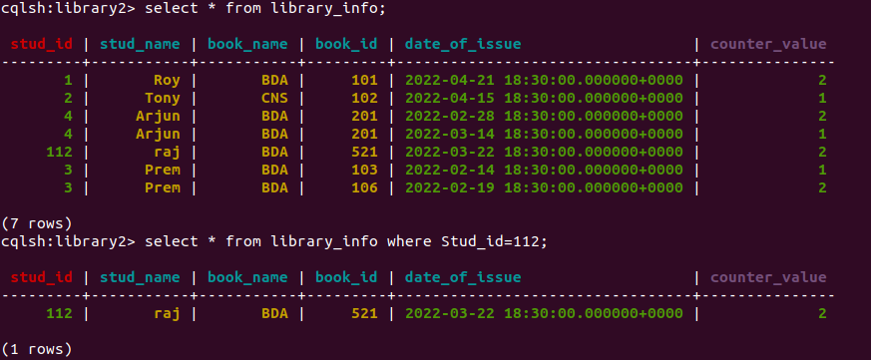
6. Export the created column to a csv file

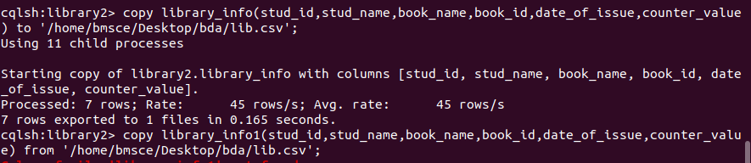
7. Import a given csv dataset from local file system into Cassandra column family
